LPG Insight Intelligence Platform for Shortage Analysis

This project is completely based on my own idea and understanding of a real-world situation. I selected the topic of LPG shortage because it is a common and relevant issue that affects many people in daily life. Based on this present situation, I decided to create my own dataset instead of using any existing data.
First, I analyzed the problem and thought about what kind of information is required to understand LPG shortages. I identified different aspects such as supply, demand, delivery delays, customer types, location details, and external factors like weather conditions and emergency situations. Based on this understanding, I manually designed the structure of the dataset, including the tables and columns.
After finalizing the structure, I started collecting and generating the data. I created around 20,000 rows of data with multiple columns to simulate a real-world environment. The data was prepared carefully to reflect realistic conditions such as variations in demand, shortages, and operational challenges.
I used Microsoft Excel as the initial tool for data preparation and organization. In Excel, I created column headers based on my planned structure and ensured that each column represented a meaningful attribute related to the LPG supply process. I also formatted the dataset by adjusting column widths, aligning the data properly, and applying header styling such as colors to improve readability and presentation.
Additionally, I ensured consistency in the data by maintaining proper formats for numbers and text fields. I reviewed the dataset multiple times to check for any inconsistencies or errors and made necessary corrections. The goal was to create a clean and well-structured dataset that could be used for further analysis.
Overall, this process helped me understand how real-world data is structured and prepared. By creating the dataset from scratch, I was able to apply my own logic and thinking to simulate a real-life LPG shortage scenario, which forms the foundation of this project.

🏆 PROJECT TITLE
“LPG Insight Intelligence Platform for Shortage Analysis”

📊 DATASET DETAILS
- Total Records: 20,000 rows
- Total Columns: 20+ columns
- Data Type: CSV (Excel-based raw data)
- Data includes: Demand, Supply, Shortage, Delay, Location, Supplie

PROJECT WORKFLOW

🔷 1. EXCEL (DATA CREATION)
Data was manually created in Excel based on real-world LPG shortage scenarios.
Column headers, formatting, and structure were defined.

🔷 2. SQL (DATA PROCESSING & CLEANING)
- Database creation
- Table creation (Fact & Dimension tables)
- Data loading using wizard
- Removing duplicates
- Handling NULL values
- Applying filters and aggregations
- Performing joins between tables
- Calculating total shortage, demand, delay

🔷 3. POWER BI (VISUALIZATION & DASHBOARD)
- Data loading from CSV
- Data cleaning using Power Query
- Creating relationships (Star Schema)
- Creating DAX measures:
  - Total Shortage
  - Total Demand
  - Fulfillment %
  - Shortage %
- Creating visuals:
  - Bar charts
  - Line charts
  - Pie charts
  - KPI cards
  - Slicers
- Building interactive dashboard

🔷 4. PYTHON (PANDAS, NUMPY, VISUALIZATION)

Pandas:
- Data loading (CSV)
- Data cleaning (duplicates, nulls)
- Merging tables (joins)
- Groupby operations
- Aggregations

NumPy:
- Numerical calculations
- Statistical operations
Visualization (Matplotlib / Seaborn):
- Bar chart (Shortage by State)
- Line chart (Monthly Trend)
- Pie chart (Customer Type)
- Demand vs Supply chart
- Area / Line chart (Daily Shortage)
- Horizontal bar (State Ranking)
- Donut chart (Strike Impact)
- Box plot & Violin plot (Delay Analysis)

FINAL SHORT NOTE
This project demonstrates complete data analysis workflow using Excel, SQL, Power BI, and Python to analyse LPG shortage.

🔷 About the Project (Topic Overview)
- This project focuses on analyzing the current issue of LPG shortage, which affects households and supply systems in real life.
- The dataset used in this project is self-designed, based on real-world understanding and logical assumptions.
- It represents various aspects such as demand, supply, shortages, delivery delays, and influencing factors.
- The project aims to study how different factors impact LPG availability and distribution.

🔷 Key Focus Areas
- Understanding the gap between demand and supply
- Identifying regions or locations with higher shortages
- Analyzing the effect of delivery delays and supplier performance
- Studying the impact of external factors like weather, strikes, and emergency supply
- Evaluating customer demand patterns.

🔷 Objective of the Project
- To simulate a real-world LPG shortage scenario using a custom dataset
- To organize and structure the data for meaningful analysis
- To derive insights that help in better supply chain understanding
- To demonstrate data handling, preparation, and analytical thinking.

🔷 Project Significance
- Highlights a real-life problem affecting daily needs
- Shows the ability to design and work with custom data
- Helps in understanding data-driven decision making
- Demonstrates practical knowledge of data analysis workflow

📄 SQL Work – Documentation Script

In this project, Structured Query Language (SQL) was used to organize, manage, and analyze the LPG shortage dataset. After preparing the dataset, it was imported into a relational database system where multiple tables were created, including one fact table and several dimension tables. These tables were structured to represent different aspects of the LPG supply system, such as location, time, supplier, and customer details.
Initially, basic SQL scripts were used to create the database and tables with appropriate column definitions and data types. The dataset was then inserted into these tables using insert operations. Once the data was available in the database, various SQL queries were executed to clean, validate, and analyze the data.
Data cleaning operations included identifying and removing duplicate records, handling missing values using functions like COALESCE, and verifying data consistency. Filtering techniques were applied using WHERE clauses to extract specific records, such as identifying high shortage cases or delayed deliveries.
Aggregation queries were performed using functions like SUM, COUNT, and AVERAGE to calculate total shortages, total demand, and average delivery delays. GROUP BY clauses were used to summarize data based on categories such as location, supplier, and time. These queries helped in identifying patterns and trends in the dataset.
Join operations were used to combine data from the fact table and dimension tables. This enabled a complete view of the dataset by linking numerical data with descriptive attributes such as state, supplier name, and customer type. These joins were essential for building a structured and meaningful dataset for further analysis.
Additionally, advanced SQL concepts such as subqueries and window functions were applied. For example, ranking functions were used to identify top locations with the highest LPG shortages, and cumulative calculations were performed to analyze trends over time.
Overall, SQL played a crucial role in transforming raw data into structured and meaningful information. It helped in preparing the dataset for visualization and ensured that the data was clean, consistent, and ready for further analysis in Power BI.

📄 SQL Documentation Script

Use of SQL in the Project
Structured Query Language (SQL) was used extensively in this project to design, manage, and analyze the LPG shortage dataset. The SQL environment was used to create the database structure, clean the data, and perform analytical queries to extract meaningful insights.
The dataset was organized into a fact table and multiple dimension tables, forming a star schema model. This structure helps in efficient data storage and retrieval for analytical purposes.
Database and Table Creation
The first step involved creating a database and defining tables using Data Definition Language (DDL) commands. Tables such as fact_lpg_shortage, dim_location, dim_time, dim_supplier, and dim_customer were created with appropriate data types and primary keys.
Each table was designed to represent a specific aspect of the LPG supply system, ensuring proper organization of data.

Data Insertion and Preparation
Data was inserted into the tables using SQL insert operations. After loading the data, SQL queries were used to verify the correctness and completeness of the dataset.

Data Cleaning Operations
SQL was used to perform data cleaning tasks, ensuring data quality and consistency. The following operations were performed:
- Removal of duplicate records using DISTINCT and GROUP BY
- Handling missing values using functions like COALESCE
- Verification of unique keys in dimension tables
- Ensuring proper data formats for numerical and textual fields

Filtering and Conditional Queries
Filtering operations were performed using WHERE clauses to extract specific data based on conditions. For example, queries were used to identify high shortage records, delayed deliveries, and specific supplier performance.

Aggregation Queries
Aggregation functions such as SUM, COUNT, and AVERAGE were used to calculate key metrics:
- Total shortage
- Total demand
- Average delivery delay
GROUP BY clauses were used to summarize data by categories such as state, supplier, and time period.

Join Operations
SQL join operations were used to combine data from the fact table and dimension tables. These joins enabled the integration of numerical data with descriptive attributes such as location, time, and supplier details.
This step was essential for building a complete dataset for analysis.

Advanced SQL Techniques
Advanced SQL features were also applied to enhance analysis:
- Subqueries were used for nested calculations
- Window functions such as RANK() were used to identify top-performing or worst-performing entities
- CASE statements were used to categorize data into meaningful groups

SQL Work Space

Cleaning And Creating

📄 SQL Data Loading Process
Overview
The data loading process into SQL was performed in a structured manner using a graphical interface (wizard-based approach). The dataset, which was initially prepared in CSV format, was systematically imported into the database by creating the necessary database and tables.

1: Database Creation
The first step involved creating a new database to store the LPG shortage dataset. This database was designed to organize all related tables in a structured manner. The database acts as a central repository for storing and managing the data.

2: Table Creation
After creating the database, individual tables were created based on the data structure. The dataset was divided into one fact table and multiple dimension tables, such as location, time, supplier, and customer.
Each table was designed with appropriate column names and data types to ensure proper storage and consistency of data.

3: Using Import Wizard
The data was then loaded into the tables using the SQL import wizard. This tool allows easy loading of CSV files into database tables without writing manual queries.
For each table, the corresponding CSV file was selected, and the wizard guided the process of mapping columns and defining data formats.

4: Table-wise Data Loading
Data was loaded into each table separately. Each CSV file was imported into its respective table, ensuring that:
- Column names matched correctly
- Data types were properly assigned
- No data misalignment occurred
This step ensured that all tables were populated with accurate data.

5: Data Verification
After loading the data, verification was performed to ensure that the data was correctly imported. This included checking:
- Number of records in each table
- Column values and formats
- Presence of any missing or incorrect data

6: Establishing Relationships
Once all tables were loaded, relationships between fact and dimension tables were established using key columns such as location_id, time_id, supplier_id, and customer_id.
This step ensured that the data model was properly structured and ready for analysis.

7: Data Readiness
After completing the loading and verification process, the dataset was ready for further operations such as data cleaning, querying, and analysis using SQL.

QUARYIES

create database lpg_shortage_analysis;
USE lpg_shortage_analysis;

create database lpg_shortage_analysis;
USE lpg_shortage_analysis;

CREATE TABLE dim_location (
location_id INT PRIMARY KEY,
city VARCHAR(50),
state VARCHAR(50),
region VARCHAR(50)
);

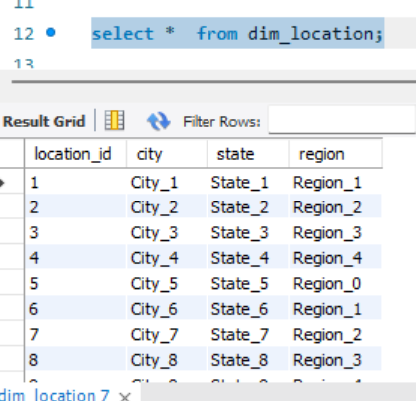

CREATE TABLE dim_time (
time_id INT PRIMARY KEY,
date DATE,
day INT,
month INT,
quarter INT,
year INT
);

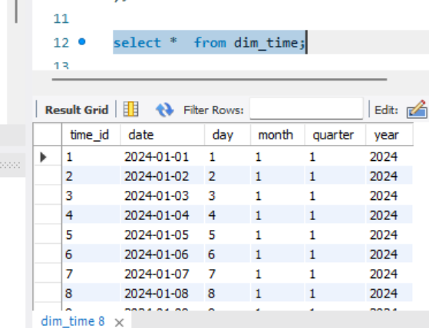

CREATE TABLE dim_supplier (
supplier_id INT PRIMARY KEY,
supplier_name VARCHAR(50),
supplier_type VARCHAR(20),
rating DECIMAL(3,2)
);
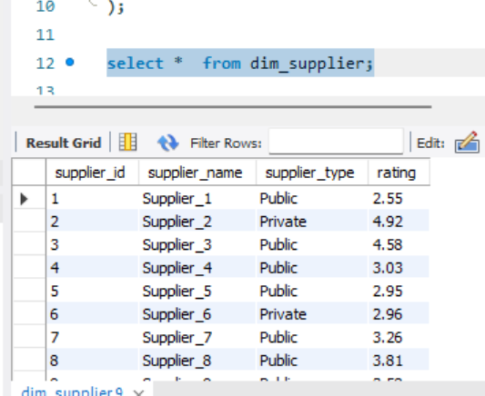

CREATE TABLE dim_customer (
customer_id INT PRIMARY KEY,
customer_type VARCHAR(20),
income_group VARCHAR(20),
connection_type VARCHAR(30)
);

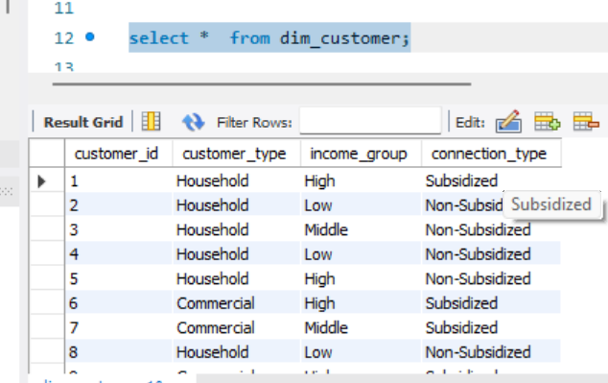

USE lpg_shortage_analysis;

CREATE TABLE fact_lpg_shortage (
transaction_id INT PRIMARY KEY,
location_id INT,
supplier_id INT,
time_id INT,
customer_id INT,
demand_cylinders INT,
supply_cylinders INT,
shortage_cylinders INT,
price_per_cylinder DECIMAL(10,2),
subsidy_amount DECIMAL(10,2),
delivery_delay_days INT,
stock_available INT,
transport_cost DECIMAL(10,2),
weather_impact_score DECIMAL(3,2),
strike_impact_flag TINYINT,
festival_demand_flag TINYINT,
emergency_supply_flag TINYINT,
warehouse_capacity INT,
fulfilled_orders INT,
unfulfilled_orders INT
);

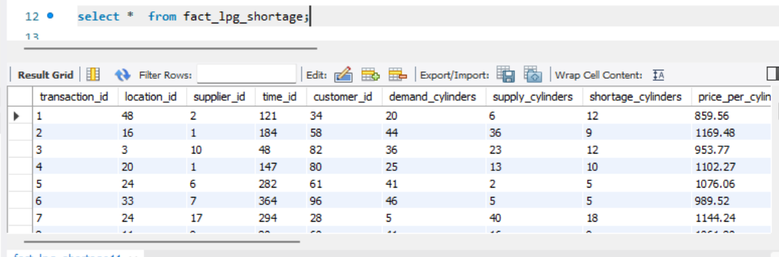

## Remove duplicates

SELECT DISTINCT *
FROM fact_lpg_shortage;

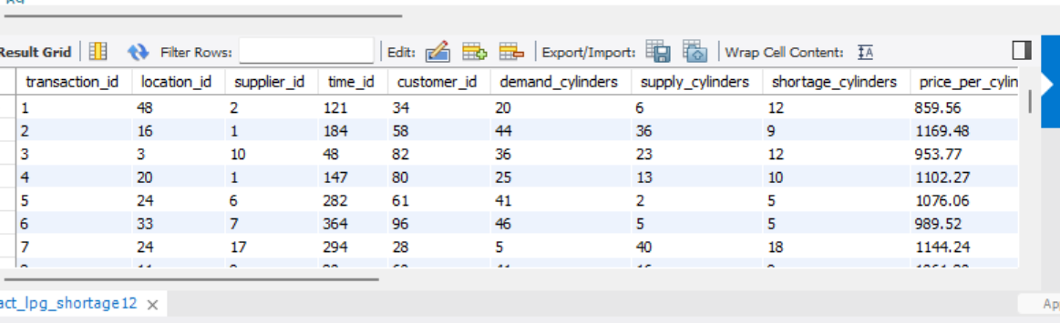
## Find duplicate records

SELECT transaction_id, COUNT(*)
FROM fact_lpg_shortage
GROUP BY transaction_id
HAVING COUNT(*) > 1;

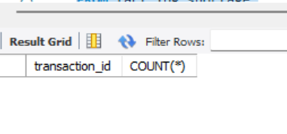

## Filter high shortage records

SELECT *
FROM fact_lpg_shortage
WHERE shortage_cylinders > 10;

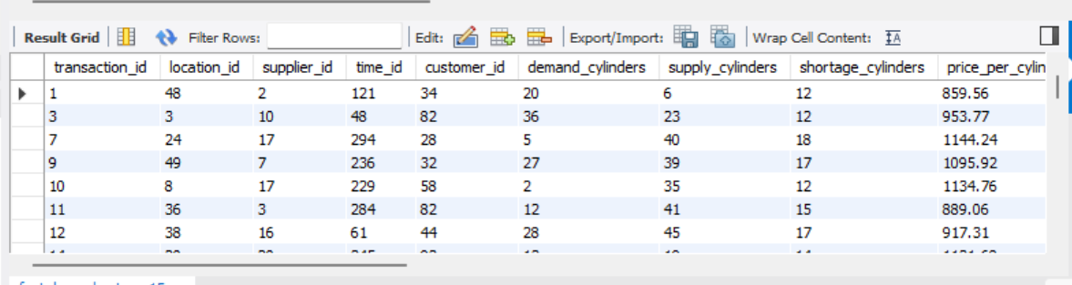

## Replace NULL values (if any)
SELECT
COALESCE(subsidy_amount, 0) AS subsidy_amount
FROM fact_lpg_shortage;

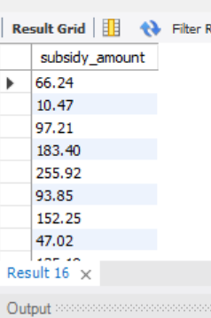

## AGGREGATIONs
## Total shortage by location

SELECT l.state, SUM(f.shortage_cylinders) AS total_shortage
FROM fact_lpg_shortage f
JOIN dim_location l ON f.location_id = l.location_id
GROUP BY l.state
ORDER BY total_shortage DESC;

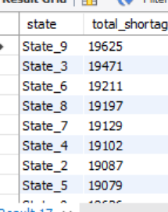

## Monthly shortage trend

SELECT t.month, SUM(f.shortage_cylinders) AS total_shortage
FROM fact_lpg_shortage f
JOIN dim_time t ON f.time_id = t.time_id
GROUP BY t.month
ORDER BY t.month;

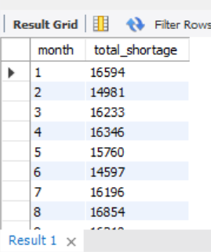

Supplier performance

SELECT s.supplier_name,
AVG(f.delivery_delay_days) AS avg_delay,
SUM(f.shortage_cylinders) AS shortage
FROM fact_lpg_shortage f
JOIN dim_supplier s ON f.supplier_id = s.supplier_id
GROUP BY s.supplier_name
ORDER BY avg_delay DESC;

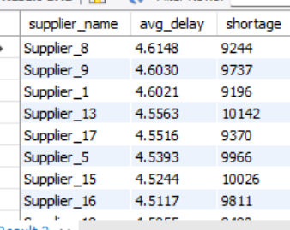

## Impact of strikes

SELECT strike_impact_flag,
AVG(shortage_cylinders) AS avg_shortage
FROM fact_lpg_shortage
GROUP BY strike_impact_flag;

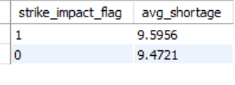

## Festival demand impact

SELECT festival_demand_flag,
SUM(demand_cylinders) AS total_demand
FROM fact_lpg_shortage
GROUP BY festival_demand_flag;
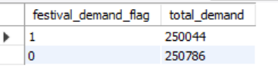

## Weather impact on shortage

SELECT
CASE
WHEN weather_impact_score > 0.7 THEN 'High Impact'
WHEN weather_impact_score > 0.4 THEN 'Medium Impact'
ELSE 'Low Impact'
END AS weather_category,
AVG(shortage_cylinders) AS avg_shortage
FROM fact_lpg_shortage
GROUP BY weather_category;

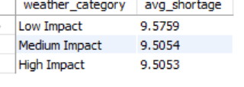

## Running total shortage

SELECT t.date,
SUM(f.shortage_cylinders) OVER (ORDER BY t.date) AS running_total
FROM fact_lpg_shortage f
JOIN dim_time t ON f.time_id = t.time_id;

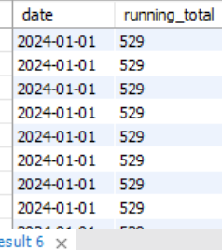

## Top 5 worst cities

SELECT l.city,
SUM(f.shortage_cylinders) AS total_shortage
FROM fact_lpg_shortage f
JOIN dim_location l ON f.location_id = l.location_id
GROUP BY l.city
ORDER BY total_shortage DESC
LIMIT 5;

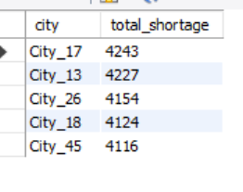

## Customer type impact

SELECT c.customer_type,
SUM(f.shortage_cylinders) AS shortage
FROM fact_lpg_shortage f
JOIN dim_customer c ON f.customer_id = c.customer_id
GROUP BY c.customer_type;

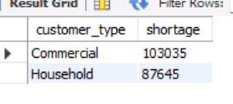

CREATE TABLE fact_final AS
SELECT
f.transaction_id,
t.time_id,
s.supplier_id,
l.location_id,
c.customer_id,
f.shortage_cylinders,
f.demand_cylinders
FROM fact_lpg_shortage f
JOIN dim_time t ON f.date = t.date
JOIN dim_supplier s ON f.supplier_name = s.supplier_name
JOIN dim_location l ON f.city = l.city
JOIN dim_customer c ON f.customer_type = c.customer_type;

Conclusion

This project analyzed LPG supply shortages using SQL-based data warehouse techniques. By applying data cleaning, filtering, aggregation, and advanced SQL operations such as joins and window functions, meaningful insights were extracted from the dataset.
The analysis identified key factors influencing shortages, including supplier performance, seasonal demand variations, and external conditions like strikes and weather impact. It also highlighted regions with higher shortages and patterns in customer demand.
Overall, this project demonstrates how SQL can be effectively used to transform raw data into actionable insights, supporting better decision-making in supply chain management.

Power bi work space

📄 1. Data Loading into Power BI
Documentation Content
The dataset was imported into Power BI using CSV files. Each table, including the fact table (fact_lpg_shortage) and dimension tables (dim_location, dim_time, dim_supplier, dim_customer), was loaded using the Get Data → Text/CSV option.
During the import process, appropriate settings such as delimiter (comma), file origin, and data type detection were verified to ensure correct data interpretation.
After loading, all tables were made available in the Power BI data model for further transformation and analysis.

📄 2. Power Query Data Cleaning
Documentation Content
Data cleaning and transformation were performed using Power Query Editor. The following steps were applied to ensure data quality and consistency:
🔹 Steps Performed:
- Removed unnecessary columns and retained only relevant fields
- Ensured correct column headers using “Use First Row as Headers”
- Removed duplicate records using Remove Duplicates to maintain uniqueness
- Handled missing values where required
- Converted data types:
  - Whole numbers for quantity-related fields (e.g., cylinders, orders)
  - Decimal numbers for monetary values (e.g., price, transport cost, subsidy)
- Renamed columns for better readability and consistency
- Checked data quality using column profiling tools

📄 3. Data Quality Validation
Documentation Content
Data quality checks were performed using Power Query profiling tools. Column quality, distribution, and profiling features were used to verify data completeness and accuracy.
It was ensured that:
- Columns show 100% valid values wherever applicable
- No unexpected null or error values exist
- Data types are consistent across all records
These steps ensured that the dataset is clean, reliable, and ready for analysis.

📄 4. Data Transformation & Loading
Documentation Content
After completing all transformation and cleaning steps in Power Query, the data was loaded into Power BI using the Close & Apply option.
The transformed dataset was then used to build relationships between fact and dimension tables, forming a star schema model. This structured data model supports efficient querying and visualization.

📄 5. Short Summary (if needed)
CSV files were imported into Power BI and cleaned using Power Query. Data transformations included removing duplicates, correcting headers, setting appropriate data types, and validating data quality. The cleaned data was then loaded into the model for analysis and visualization.

DAX measures were then created to perform dynamic calculations such as total shortage, total demand, shortage percentage, average delay, and fulfillment rate. These measures allow interactive analysis based on filters and slicers.
Various visualizations were created to represent the data effectively. Bar charts were used to analyze shortage by location, line charts were used to observe trends over time, and pie charts were used to compare different customer types. KPI cards were used to display key metrics such as total shortage and fulfillment percentage.
Slicers were added to enable interactive filtering based on attributes such as year, state, and supplier. This allowed users to explore the data dynamically and gain better insights.
Overall, Power BI was used to transform the prepared dataset into meaningful visual insights, enabling better understanding of LPG shortage patterns and supporting data-driven decision making.

Dax measures
1. Total Shortage
Total Shortage = SUM(fact_lpg_shortage[shortage_cylinders])

2. Total Demand
Total Demand = SUM(fact_lpg_shortage[demand_cylinders])

3. Total Supply
Total Supply = SUM(fact_lpg_shortage[supply_cylinders])

4. Shortage Percentage
Shortage % =
DIVIDE([Total Shortage], [Total Demand], 0) * 100
5. Average Delivery Delay
Avg Delay = AVERAGE(fact_lpg_shortage[delivery_delay_days])

6. Total Profit (Business Insight)
Total Profit =
SUMX(
fact_lpg_shortage,
(fact_lpg_shortage[price_per_cylinder] * fact_lpg_shortage[supply_cylinders])
- fact_lpg_shortage[transport_cost]
- fact_lpg_shortage[subsidy_amount]
)

7. Total Transport Cost
Total Transport Cost = SUM(fact_lpg_shortage[transport_cost])

8. Total Subsidy
Total Subsidy = SUM(fact_lpg_shortage[subsidy_amount])

9. Fulfillment Rate
Fulfillment % =
DIVIDE(
SUM(fact_lpg_shortage[fulfilled_orders]),
SUM(fact_lpg_shortage[fulfilled_orders] + fact_lpg_shortage[unfulfilled_orders]),
0
) * 100

10. Unfulfilled Orders
Unfulfilled Orders = SUM(fact_lpg_shortage[unfulfilled_orders])

11. Average Weather Impact
Avg Weather Impact = AVERAGE(fact_lpg_shortage[weather_impact_score])

12. Strike Impact Shortage
Strike Shortage =
CALCULATE(
[Total Shortage],
fact_lpg_shortage[strike_impact_flag] = 1
)

13. Festival Demand
Festival Demand =
CALCULATE(
[Total Demand],
fact_lpg_shortage[festival_demand_flag] = 1
)

14. Emergency Supply Impact
Emergency Supply =
CALCULATE(
SUM(fact_lpg_shortage[supply_cylinders]),
fact_lpg_shortage[emergency_supply_flag] = 1
)

15. Stock Utilization
Stock Utilization % =
DIVIDE(
SUM(fact_lpg_shortage[supply_cylinders]),
SUM(fact_lpg_shortage[warehouse_capacity]),
0
) * 100

POWER BI DASHBOARD DESIGN

KPI CARDS – 4

1. Total Shortage

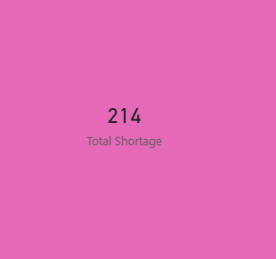

2. Total Demand

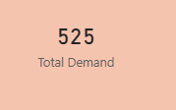

3. Shortage %

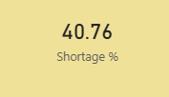

4. Fulfilment %

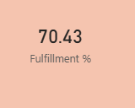

SLICERS – 4

Year
dim_time[year]
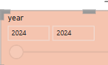

State
dim_location[state]

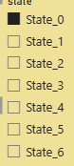

Supplier
dim_supplier[supplier_name]

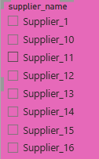

Customer Type
dim_customer[customer_type]

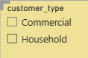

MAIN ANALYSIS CHART VISUALIZATION

COLUMN CHART – Demand vs Supply

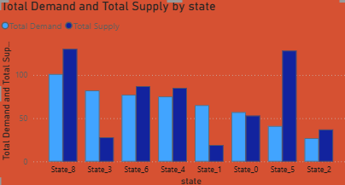

PIE CHART – Customer Type

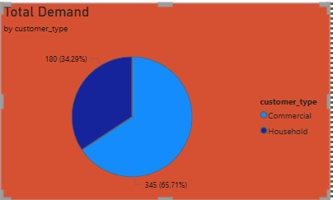

LINE CHART – Shortage Trend By Month

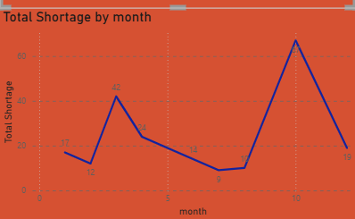

GAUGE – Fulfillment %
Shows performance clearly

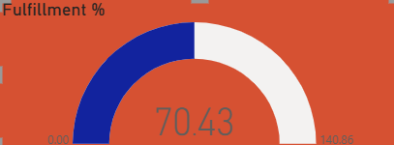

AREA CHART – Running Shortage

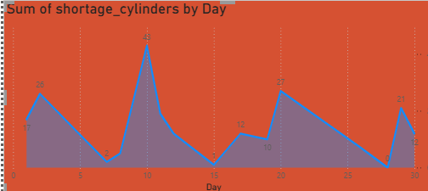

Which state is most affected
BAR CHART

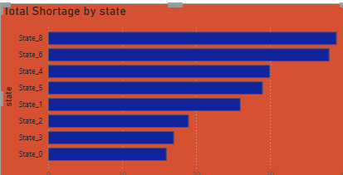

COLUMN CHART – Supplier Performance
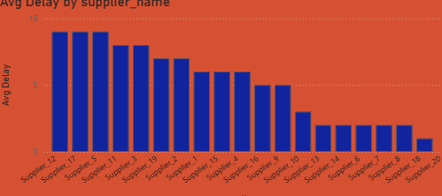
DONUT CHART – Strike Impact

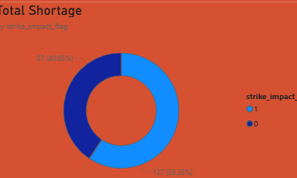

Overall analysis

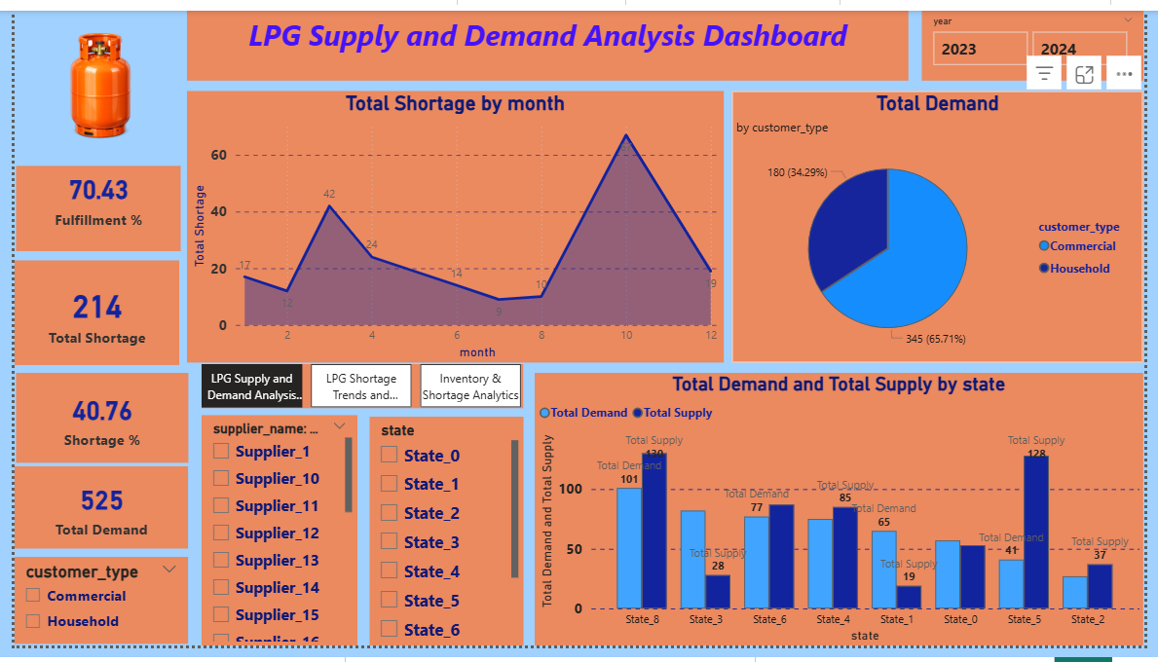

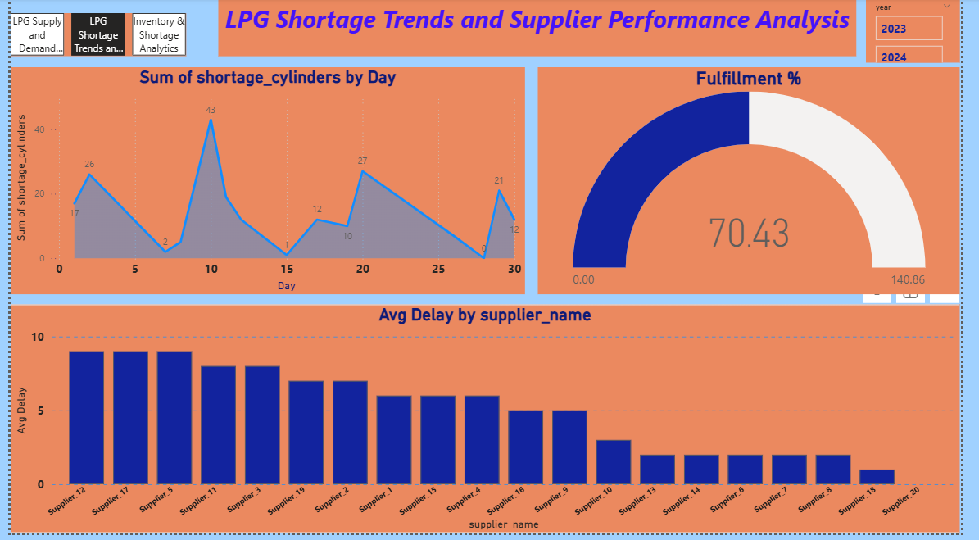

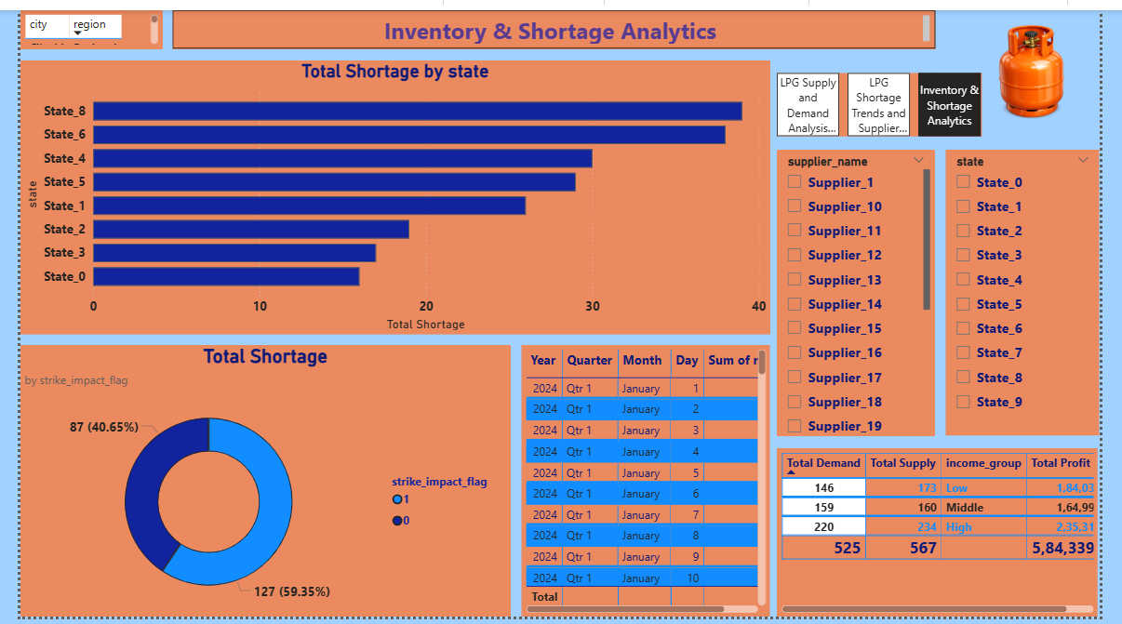

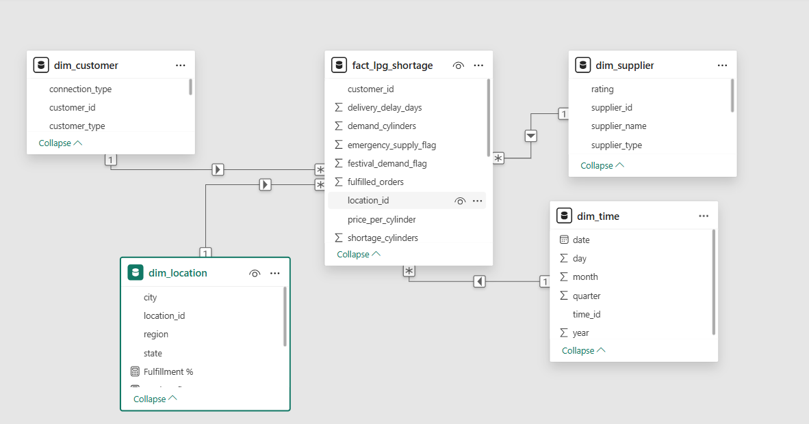

📊 POWER BI – DATA MODELING

🔷 Model View
The Model View in Power BI was used to visually design and manage relationships between tables. It provides a clear representation of how fact and dimension tables are connected, forming the foundation for data analysis.

🔷 Relationships
Relationships were created between the fact table and dimension tables using key columns. The following relationships were established:
- location_id → dim_location
- time_id → dim_time
- supplier_id → dim_supplier
- customer_id → dim_customer
These relationships enable data to be connected across tables and support accurate analysis.

🔷 Cardinality
The relationships were defined using Many-to-One ( : 1) cardinality*:
- Fact table → Many side (*)
- Dimension tables → One side (1)
This ensures proper aggregation and avoids duplication in analysis.

🔷 Cross Filter Direction
The cross filter direction was set to Single, which improves performance and ensures controlled data filtering between tables.

🔷 Star Schema Model
The data model was designed using a Star Schema structure:
- Fact table at the center
- Dimension tables connected around it
This model improves:
- Query performance
- Data clarity
- Accuracy of visualizations

📄 POWER BI PROJECT SCRIPT

Dashboard Overview
This Power BI dashboard is designed to analyze LPG supply and demand, focusing on shortage patterns and supply chain performance. The dashboard consists of multiple pages, including an overview page and a detailed analysis page. It provides insights into key metrics such as total shortage, total demand, fulfillment percentage, and shortage percentage.
Interactive features such as slicers and navigation buttons allow users to explore the data dynamically based on year, state, supplier, and customer type. The dashboard presents both high-level summaries and detailed insights, enabling better understanding of LPG distribution challenges.

KPI Cards Explanation
At the top of the dashboard, KPI cards are used to display key performance indicators:
- Total Shortage (214) shows the total number of LPG cylinders not supplied.
- Total Demand (525) represents the total customer demand.
- Fulfillment % (70.43%) indicates how much demand was successfully fulfilled.
- Shortage % (40.76%) reflects the gap between demand and supply.
These KPI cards provide a quick and clear summary of the LPG shortage situation, allowing users to understand the overall performance without analyzing detailed charts.

Slicers (Filters) Explanation
Slicers are provided on the left side of the dashboard to enable interactive filtering. Users can filter the data based on:
- State
- Supplier Name
- Customer Type
- Year
These slicers allow dynamic exploration of data, helping users analyze specific regions, suppliers, or customer segments. This interactivity improves user experience and supports detailed analysis.

Charts Explanation – Page 1 (Overview Dashboard)
Demand vs Supply by State
This bar chart compares total demand and total supply across different states. It helps identify regions where supply is insufficient compared to demand. The gap between the two bars visually represents the shortage.

Total Demand by Customer Type
This pie chart shows the distribution of demand between commercial and household customers. It helps understand which customer segment contributes more to LPG demand.

📈 Total Shortage by Month
This line chart represents the trend of LPG shortages over time. It helps identify peak shortage periods and seasonal variations.

Fulfillment Gauge
The gauge chart visually represents the fulfillment percentage. It indicates how efficiently demand is being met and highlights performance levels.

Charts Explanation – Page 2 (Detailed Analysis)
📈 Shortage by Day
This area chart shows daily fluctuations in LPG shortages. It helps analyze short-term trends and identify sudden spikes in shortages.

📊 Total Shortage by State
This horizontal bar chart ranks states based on shortage levels. It helps identify the most affected regions.

📊 Average Delay by Supplier
This chart compares suppliers based on average delivery delay. It highlights inefficient suppliers and helps evaluate supplier performance.

Shortage by Strike Impact
This donut chart shows how external factors like strikes impact LPG shortage. It helps understand how disruptions affect supply.

🔷 Navigation Explanation
Navigation buttons are used to switch between dashboard pages. This improves usability and allows users to move between overview and detailed analysis easily. The design ensures a structured flow of information.

🔷 Design and Layout Explanation
The dashboard follows a structured layout:
- Top section → KPI cards for summary
- Left panel → Slicers for filtering
- Middle section → Main analysis charts
- Bottom section → Detailed insights
Consistent color themes and alignment are used to maintain visual clarity and professional appearance.

🏁 PROJECT CONCLUSION (VERY IMPORTANT)
This project successfully demonstrates the analysis of LPG supply and demand using a self-designed dataset and Power BI. The dashboard provides both high-level and detailed insights into shortage patterns, supplier performance, and demand distribution.
The analysis reveals that LPG shortages are influenced by multiple factors such as demand fluctuations, supplier delays, and external disruptions like strikes. The comparison between demand and supply highlights the gap that leads to shortages, while fulfillment metrics indicate the efficiency of the supply system.
The use of Power BI enabled interactive and dynamic analysis through slicers and visualizations. This allows users to explore data from different perspectives and gain meaningful insights. The dashboard design ensures clarity, usability, and effective communication of information.
Overall, this project demonstrates the ability to design a complete data analysis solution, starting from data creation to visualization. It highlights the importance of data-driven decision-making in managing supply chain challenges such as LPG shortages.

FINAL
“This dashboard provides a comprehensive view of LPG shortage by combining demand, supply, and performance metrics, enabling effective analysis and decision-making.”

Python Work Space

LOAD YOUR CSV DATA
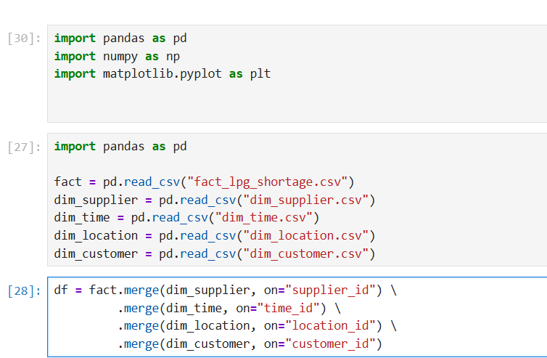

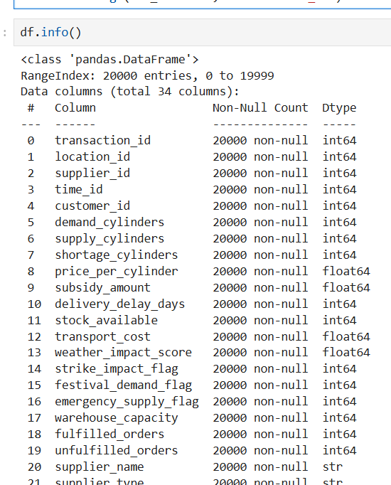

DATA CLEANING

Remove duplicates
fact = fact.drop_duplicates()

Handle NULL values
fact['subsidy_amount'] = fact['subsidy_amount'].fillna(0)

fact['shortage_cylinders'] = fact['shortage_cylinders'].astype(int)
fact['price_per_cylinder'] = fact['price_per_cylinder'].astype(float)

Filter high shortage
high_shortage = fact[fact['shortage_cylinders'] > 10]

total_shortage = fact['shortage_cylinders'].sum()
print(total_shortage)

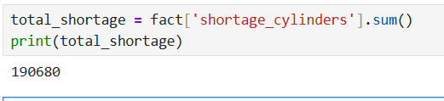

avg_delay = fact['delivery_delay_days'].mean()
print(avg_delay)

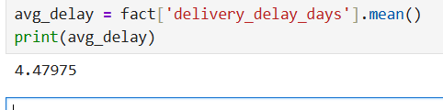

df = fact.merge(dim_location, on="location_id")

state_shortage = df.groupby('state')['shortage_cylinders'].sum().reset_index()

total_demand = df['demand_cylinders'].sum()

Shortage %
shortage_percent = (total_shortage / total_demand) * 100
print(shortage_percent)

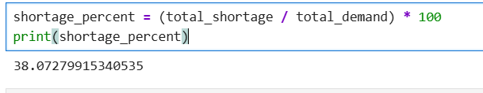

Group by State
state_shortage = df.groupby('state')['shortage_cylinders'].sum()
print(state_shortage)

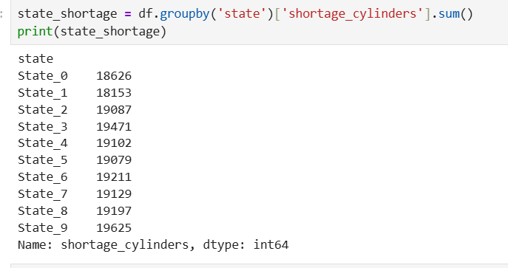

Supplier Performance

supplier_delay = df.groupby('supplier_name')['delivery_delay_days'].mean()
print(supplier_delay)

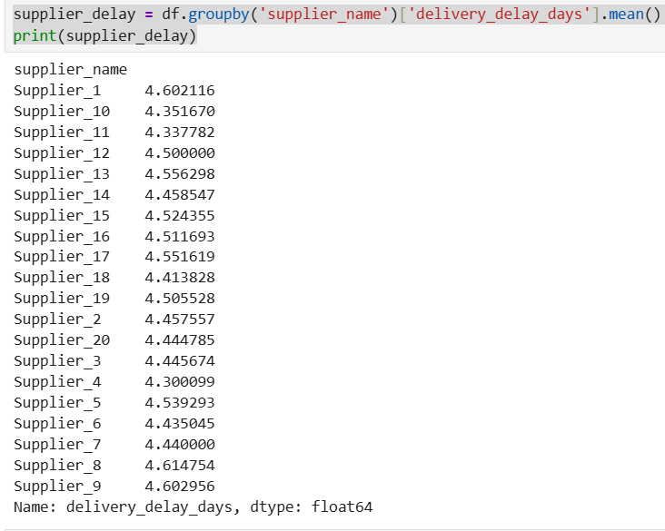

Monthly Trend

df = fact.merge(dim_time, on="time_id", how="left")

df['date'] = pd.to_datetime(df['date'])

monthly_shortage = df.groupby(df['date'].dt.month)['shortage_cylinders'].sum()

df.head()

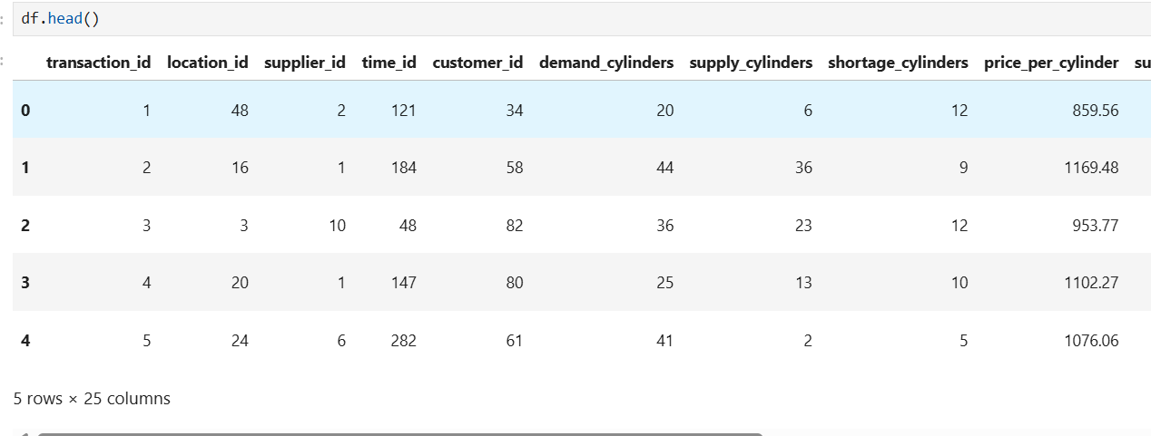

VISUALIZATIONS

1. Bar Chart – Shortage by State

state_shortage.plot(kind='bar')
plt.title("Shortage by State")
plt.xlabel("State")
plt.ylabel("Shortage Cylinders")
plt.show()

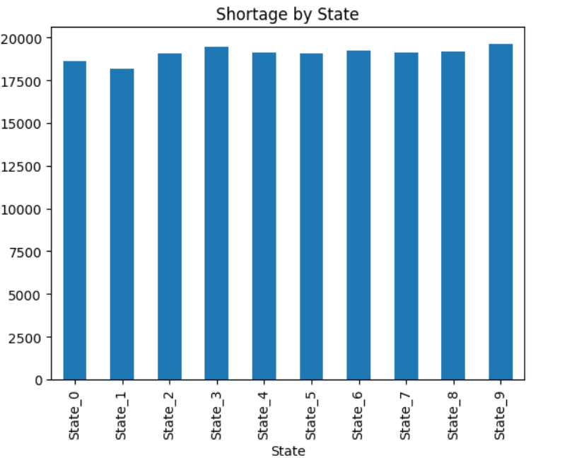

2. Line Chart – Monthly Trend

monthly_shortage.plot(kind='line')
plt.title("Monthly Shortage Trend")
plt.xlabel("Month")
plt.ylabel("Shortage")
plt.show()

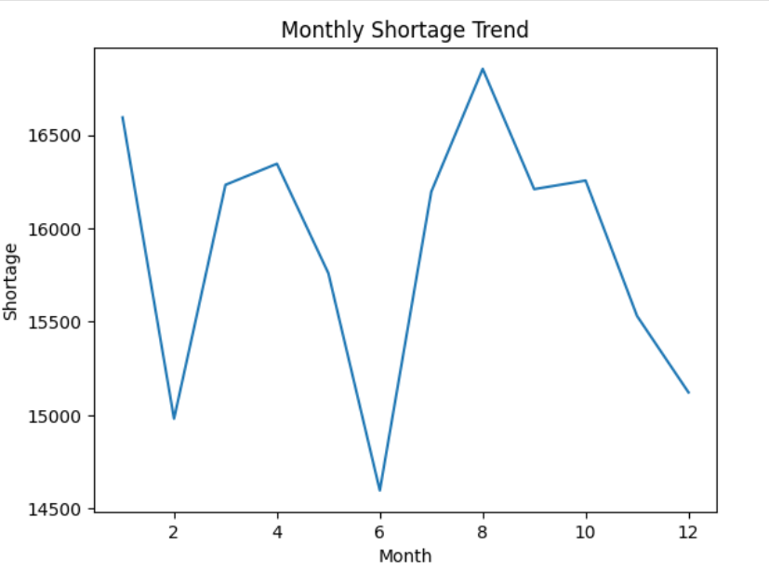

3. Pie Chart – Customer Type

df = fact.merge(dim_customer, on="customer_id", how="left")

customer_demand = df.groupby('customer_type')['demand_cylinders'].sum()

customer_demand.plot(kind='pie', autopct='%1.1f%%')
plt.title("Demand by Customer Type")
plt.ylabel("")
plt.show()

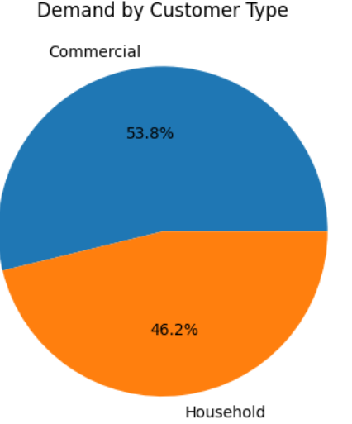

4. Supplier Performance

supplier_delay.plot(kind='bar')
plt.title("Supplier Delay Analysis")
plt.xlabel("Supplier")
plt.ylabel("Avg Delay")
plt.show()

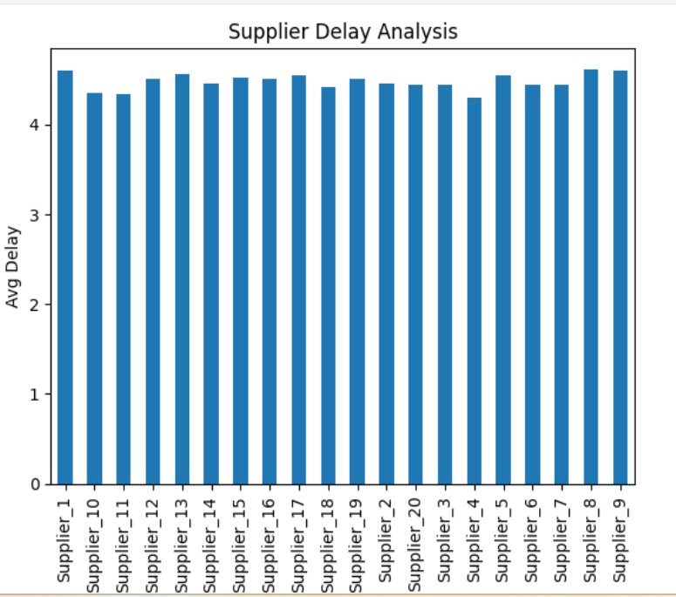

5. Demand vs Supply

df = fact.merge(dim_time, on="time_id", how="left")

df['date'] = pd.to_datetime(df['date'])
df['month'] = df['date'].dt.month

ds = df.groupby('month')[['demand_cylinders','supply_cylinders']].sum()

ds = df.groupby('month')[['demand_cylinders','supply_cylinders']].sum()
ds.plot(kind='bar')
plt.title("Demand vs Supply")
plt.show()

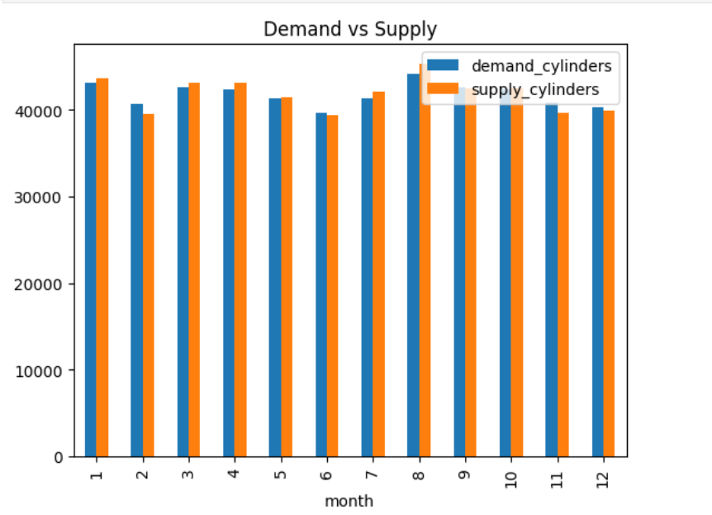

6. Area Chart – Daily Shortage

df['date'] = pd.to_datetime(df['date'])

daily_shortage = df.groupby('date')['shortage_cylinders'].sum()

daily_shortage.plot(kind='area')
plt.title("Daily LPG Shortage")
plt.xlabel("Date")
plt.ylabel("Shortage")
plt.show()

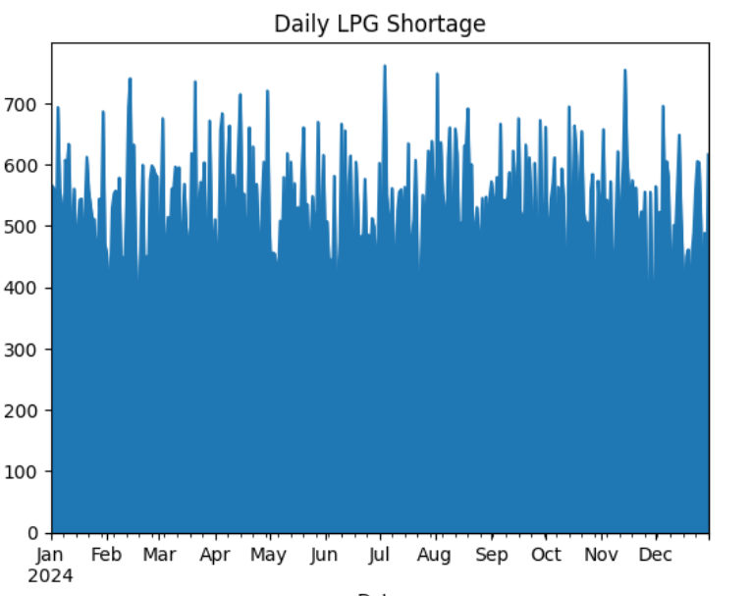

7. Horizontal Bar – State Ranking

state_shortage = df.groupby('state')['shortage_cylinders'].sum().sort_values()

state_shortage.plot(kind='barh')
plt.title("Shortage by State (Ranking)")
plt.xlabel("Shortage")
plt.show()

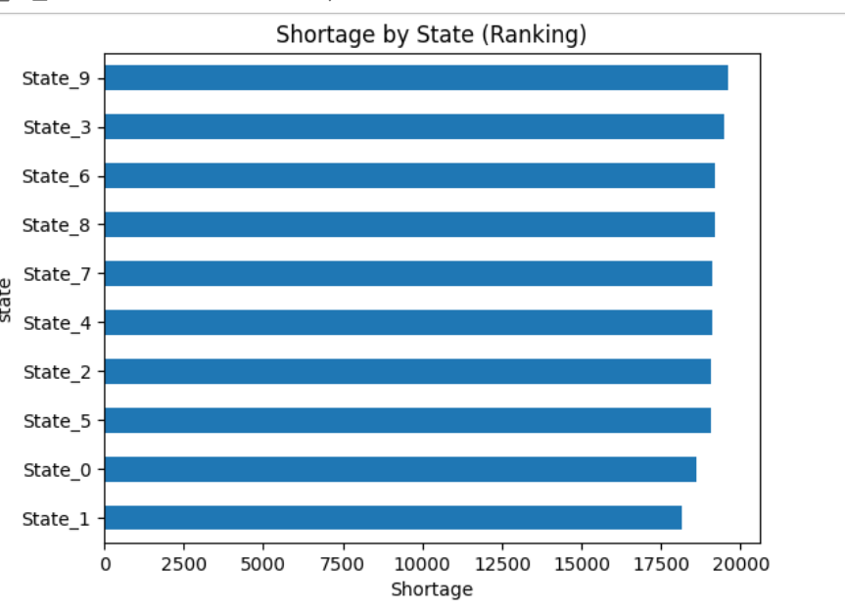

8. Donut Chart – Strike Impact

strike = df.groupby('strike_impact_flag')['shortage_cylinders'].sum()

plt.pie(strike, labels=strike.index, autopct='%1.1f%%')
plt.title("Strike Impact on Shortage")

# donut effect
centre_circle = plt.Circle((0,0),0.70,fc='white')
fig = plt.gcf()
fig.gca().add_artist(centre_circle)

plt.show()

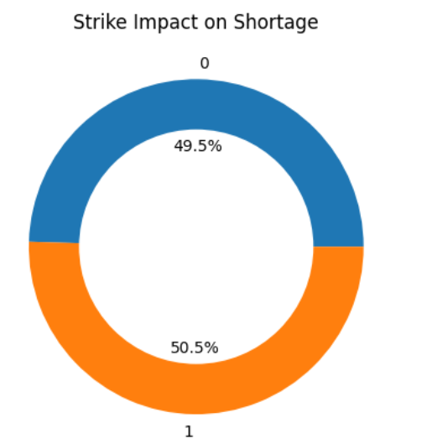

import seaborn as sns

## 9. VIOLIN PLOT Delay Distribution

sns.violinplot(y=df['delivery_delay_days'])
plt.title("Delay Distribution (Violin Plot)")
plt.show()
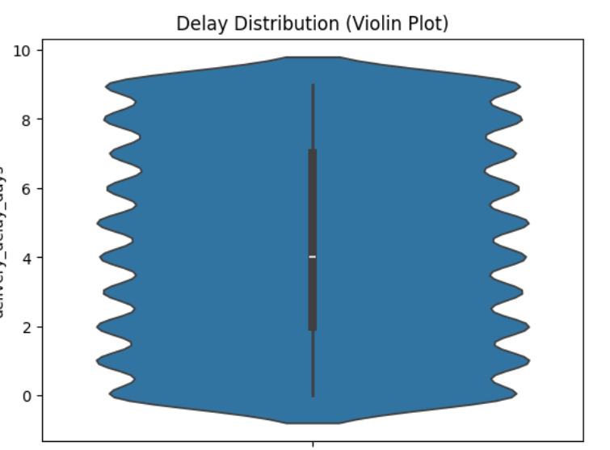

10. Box Plot – Delay Analysis

df.boxplot(column='delivery_delay_days')
plt.title("Delay Analysis")
plt.show()

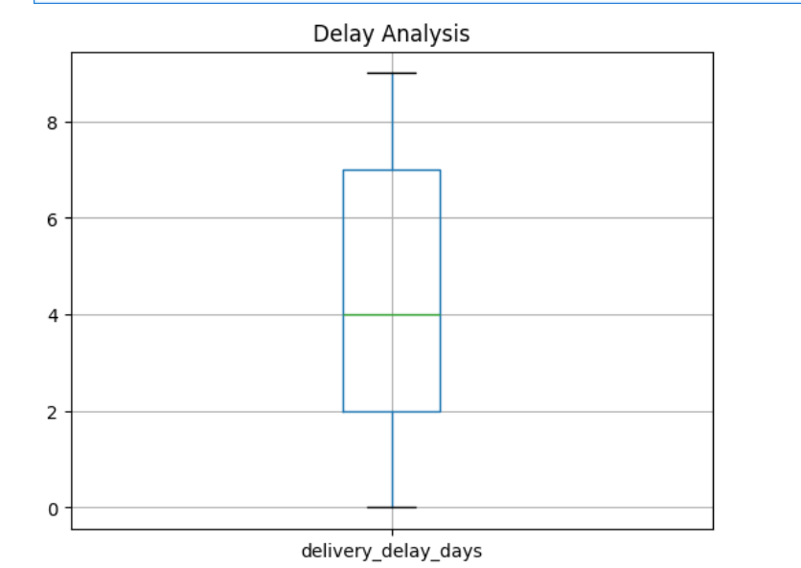

📄 PART 1: PYTHON VISUALIZATION – CHART-WISE ANALYSIS

🔷 Overview of Python Analysis
After completing data cleaning and preparation, Python (using Pandas, NumPy, and Matplotlib/Seaborn) was used to perform analytical visualization. These visualizations helped in understanding patterns, trends, and relationships in LPG shortage data. Each chart was selected based on the type of analysis required.

📊 1. Bar Chart – Shortage by State
The bar chart was used to analyze LPG shortage across different states. This visualization helps in comparing shortages between regions and identifying the most affected areas.
From the chart, it is observed that certain states experience significantly higher shortages compared to others. This indicates regional imbalance in LPG distribution and highlights areas requiring improved supply management.

📈 2. Line Chart – Monthly Shortage Trend
A line chart was used to represent LPG shortages over time (monthly). This chart helps identify trends such as increasing or decreasing shortages.
The analysis shows fluctuations in shortages across months, indicating possible seasonal demand variations or supply chain inefficiencies. Peaks in the graph represent critical periods where shortages are high.

🥧 3. Pie Chart – Customer Type Demand
The pie chart shows the distribution of LPG demand across different customer types (e.g., commercial vs household).
The visualization indicates that one category contributes a larger share of total demand. This insight is useful for prioritizing supply and understanding consumption patterns.

📊 4. Supplier Performance Chart
A bar chart was used to evaluate supplier performance based on delivery delay.
The chart highlights which suppliers have higher delays, indicating inefficiencies. Suppliers with lower delays are more reliable, while those with higher delays contribute to shortages.

📊 5. Demand vs Supply Chart
This chart compares total demand and supply over time.
The gap between demand and supply represents the shortage. A consistent gap indicates structural issues in supply planning, while fluctuations show temporary imbalances.

📊 6. Area Chart – Daily Shortage
The area chart was used to visualize daily shortage trends.
However, due to high data density, the chart appeared cluttered. This indicates that for large datasets, aggregation or smoothing techniques are more effective.

📊 7. Horizontal Bar Chart – State Ranking
A horizontal bar chart was used to rank states based on shortage levels.
This visualization clearly shows which states are most and least affected, making it easier to prioritize actions.

🍩 8. Donut Chart – Strike Impact
The donut chart shows the impact of strike conditions on LPG shortages.
The analysis indicates that shortages increase significantly during strike periods, highlighting the importance of operational stability.

📊 9. Violin Plot – Delay Distribution
The violin plot provides a detailed view of delivery delay distribution.
It shows the density and spread of delays, helping identify whether delays are concentrated or widely distributed.

📊 10. Box Plot – Delay Analysis
The box plot summarizes delivery delay using median, quartiles, and outliers.
It reveals:
- Typical delay range
- Presence of extreme delays (outliers)
- Overall distribution pattern
This helps in identifying abnormal supplier behavior.

🧠 Python Analysis Summary
Python visualization enabled deeper analysis beyond standard reporting. It helped in understanding distribution patterns, trends, and relationships in data, providing both basic and advanced insights.

📄 PART 2: FINAL INTEGRATED ANALYSIS (SQL + POWER BI + PYTHON)

🔷 Project Overview
This project focuses on analyzing LPG shortage using a self-created dataset based on real-world scenarios. The analysis was performed using multiple tools including Excel, SQL, Power BI, and Python. Each tool played a specific role in the overall data analytics pipeline.

🔷 Role of Excel
Excel was used for initial data preparation.
The dataset was manually created, structured, and formatted. Column headers were defined, and basic organization was performed to ensure consistency.

🔷 Role of SQL
SQL was used for:
- Database creation
- Table design (fact and dimension tables)
- Data cleaning (removing duplicates, handling nulls)
- Data aggregation and querying
SQL ensured that the dataset was structured, consistent, and ready for analysis.

🔷 Role of Power BI
Power BI was used for:
- Data transformation using Power Query
- Creating relationships (star schema)
- Building DAX measures
- Designing interactive dashboards
Visualizations such as KPI cards, bar charts, line charts, and pie charts were used to present insights in an interactive format.

🔷 Role of Python (Pandas, NumPy, Matplotlib)
Python was used for:
- Advanced data analysis
- Data manipulation using Pandas
- Numerical operations using NumPy
- Visualization using Matplotlib and Seaborn
Python allowed deeper exploration of data patterns and provided flexibility for custom analysis.

🔷 Key Insights from the Project
The analysis revealed several important insights:
- There is a significant gap between demand and supply, leading to LPG shortages
- Certain regions consistently experience higher shortages
- Supplier performance (delivery delay) directly impacts shortage levels
- External factors such as strikes significantly increase shortages
- Demand patterns vary across customer types and time periods

🏁 FINAL CONCLUSION (VERY IMPORTANT)
In conclusion, this project demonstrates a complete data analytics workflow using multiple tools. Starting from data creation in Excel, processing in SQL, visualization in Power BI, and advanced analysis in Python, the project provides a comprehensive understanding of LPG shortage patterns.
The findings highlight the importance of efficient supply chain management, supplier performance, and external factors in determining LPG availability. The use of multiple tools ensures both technical depth and business-level insights.
SQL provided a strong foundation for data organization, Power BI enabled interactive and user-friendly visualization, and Python offered advanced analytical capabilities. Together, these tools created a powerful and complete analytical solution.
This project not only demonstrates technical skills but also reflects the ability to solve real-world problems using data-driven approaches.

M HEMALATHA
THANK YOU

